Part 4 - Real-Time Transaction Analysis using Spark Structured Streaming
Project Title - Financial Forecasting Frontier: Distributed Machine Learning for Banking Analytics

Objective
The objective of this phase is to implement a real-time data processing system using Apache Spark Structured Streaming. Banking systems continuously receive new customer transactions and marketing records. Instead of processing data only after it has been stored, streaming enables banks to analyze incoming information immediately and generate timely business insights.
This project simulates a real-time banking environment by processing continuously arriving CSV files using Spark Structured Streaming.

Introduction
Modern financial institutions process thousands of customer interactions every second. Traditional batch processing introduces delays because data is analyzed only after large amounts have accumulated.
Spark Structured Streaming enables continuous processing of incoming data streams by dividing the data into small micro-batches. This allows banks to detect important events quickly, generate alerts, and improve operational efficiency.
In this project, streaming is simulated using a directory where new CSV files are periodically added. Spark automatically detects these files and processes them without requiring the application to restart.

Why Real-Time Streaming is Important in Banking
Real-time analytics has become an essential component of modern banking systems.
Some common banking applications include:
- Fraud detection
- Suspicious transaction monitoring
- Customer activity tracking
- Live campaign monitoring
- Instant business dashboards
- Risk management
- Compliance monitoring
- Real-time customer alerts
Streaming enables organizations to react immediately instead of waiting for scheduled batch processing.

Technologies Used
- Apache Spark Structured Streaming
- PySpark
- Spark SQL
- CSV File Streaming
- Python

Streaming Architecture
The implemented streaming workflow consists of the following stages:
- Incoming banking data is placed into a streaming input directory.
- Spark continuously monitors the directory for newly added CSV files.
- Each new file is treated as a micro-batch.
- The data is validated using a predefined schema.
- Rule-based analysis is performed on the incoming records.
- Results are displayed or written to the configured output sink.
- The streaming application continues running until it is stopped.
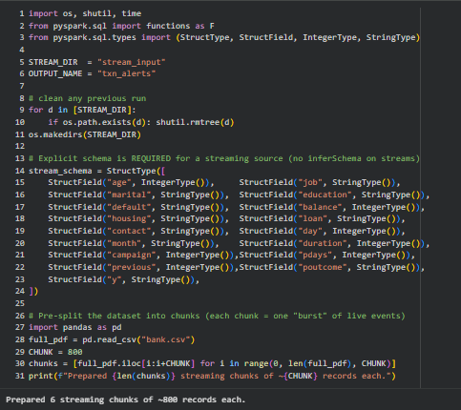
This architecture demonstrates how continuous data processing works in enterprise banking systems.

Schema Definition
Unlike batch processing, Spark Structured Streaming cannot automatically infer the schema of incoming files.
Therefore, a complete schema is explicitly defined before the streaming process begins.
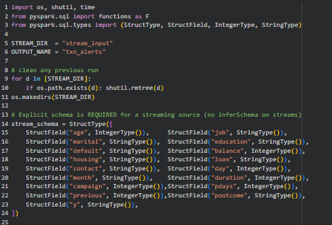
Defining the schema provides several benefits:
- Faster execution
- Consistent data types
- Reduced processing errors
- Improved streaming performance

Reading Streaming Data
The streaming application continuously reads customer data from the monitored directory using Spark's streaming DataFrame.
Each newly added CSV file automatically becomes part of the processing pipeline.
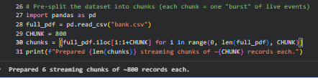
This eliminates the need for manually reloading the dataset whenever new information becomes available.

Micro-Batch Processing
Spark Structured Streaming processes data using the micro-batch model.
The workflow is:
- Detect new files
- Read incoming records
- Process records
- Apply business rules
- Generate output
- Wait for additional files
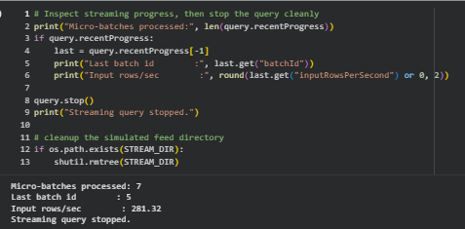
This approach combines the advantages of batch processing with the responsiveness required for real-time analytics.

Rule-Based Transaction Analysis
The project includes a rule engine that evaluates each incoming record.
Examples of business rules include:
- Customers with unusually high account balances
- Customers contacted excessively during campaigns
- Potential high-value marketing opportunities
- Customers requiring immediate follow-up
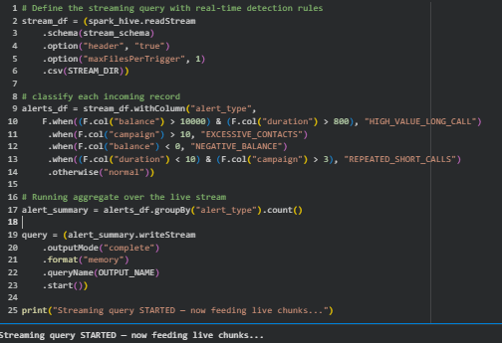
The generated results can be used to support business decisions or trigger operational alerts.

Output Processing
After processing each micro-batch, the streaming application outputs the results.
Possible output destinations include:
- Console output
- Files
- Databases
- Dashboards
- Monitoring systems
In this implementation, the processed streaming results are displayed to demonstrate continuous execution.

Business Applications
Real-time streaming can significantly improve banking operations.
Examples include:
Fraud Detection
Transactions that exceed predefined thresholds can be identified immediately for further investigation.
Customer Alerts
Banks can notify customers instantly when important account activities occur.
Marketing Campaign Monitoring
Campaign performance can be evaluated while the campaign is still running, allowing marketing strategies to be adjusted in real time.
Risk Monitoring
Potential financial risks can be detected before they significantly impact business operations.

Advantages of Spark Structured Streaming
Using Spark Structured Streaming provides several advantages:
- Real-time processing
- Distributed execution
- Fault tolerance
- Horizontal scalability
- Automatic recovery
- Seamless integration with Spark SQL and Spark ML
- Efficient processing of continuous data streams
These capabilities make Spark an ideal platform for modern banking analytics.

Challenges Faced
Several challenges were encountered while implementing the streaming workflow:
- Defining an explicit schema for streaming data.
- Simulating continuous data arrival using CSV files.
- Understanding the micro-batch execution model.
- Managing streaming queries correctly.
- Ensuring compatibility between batch and streaming operations.
These challenges provided valuable insights into designing reliable streaming applications.

Learning Outcomes
This phase provided practical experience in real-time distributed data processing.
Key learnings include:
- Understanding Spark Structured Streaming.
- Working with streaming DataFrames.
- Implementing schema-based streaming.
- Processing micro-batches efficiently.
- Applying rule-based analytics to streaming data.
- Appreciating the importance of real-time analytics in banking systems.

Future Enhancements
The streaming system can be extended further by integrating:
- Apache Kafka for live event ingestion.
- Real-time fraud detection models.
- Machine learning predictions on streaming data.
- Cloud-based streaming platforms.
- Interactive monitoring dashboards.
- Automated notification systems.
These enhancements would make the system suitable for enterprise-scale production environments.

Conclusion
The Spark Structured Streaming implementation successfully demonstrated how banking institutions can process continuously arriving customer data in real time. By simulating live data ingestion, defining an explicit schema, and processing each micro-batch efficiently, the system illustrates the advantages of distributed streaming over traditional batch processing. Real-time analytics enables faster decision-making, improved fraud detection, enhanced customer service, and more responsive business operations, making it an essential component of modern banking data systems.

